Monster Mash Charts Name_____________________________ Period_____ | MOTHER MONSTER |  | FATHER MONSTER |  | PUNNETT SQUARE | BABY MONSTER
CHARACTERISTIC | GENOTYPE | PHENOTYPE | GENOTYPE | PHENOTYPE | POSSIBILITIES  &  PROBABILITIES | RANDOM NUMBER 1-4 AND GENOTYPE | PHENOTYPE
CLASS EXAMPLE:  DON’T DRAW ON MONSTER!  HAIR  C = CURLY  c = STRAIGHT
   |  | Dad
  Mom |  | ¹ | ²
  Mom |  | ³ | ⁴
BODY SHAPE  B = TRIANGLE  b = SQUARE  COLOR = BLUE | __ __ |  | __ __
   |  | Dad
  Mom |  | ¹ | ²
  Mom |  | ³ | ⁴
HEAD SHAPE  H = ROUND  h = SQUARE  COLOR = RED | __ __ |  | __ __
   |  | Dad
  Mom |  | ¹ | ²
  Mom |  | ³ | ⁴
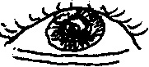  EYES  E = 1 HUMAN  e = 3 HUMAN eyes  COLOR = ORANGE | __ __ |  | __ __
   |  | Dad
  Mom |  | ¹ | ²
  Mom |  | ³ | ⁴
HAIR  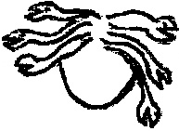  A = MEDUSA  (SNAKES)  a = PUNK 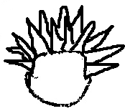  COLOR = PINK | __ __ |  | __ __
   |  | Dad
  Mom |  | ¹ | ²
  Mom |  | ³ | ⁴
TAIL  T = PIG 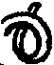  t = DRAGON 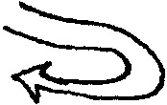  COLOR = BLUE | __ __ |  | __ __
   |  | Dad
  Mom |  | ¹ | ²
  Mom |  | ³ | ⁴
BREATH  F = FIERY 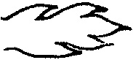  f = NOT FIERY  COLOR = RED | __ __ |  | __ __
   |  | Dad
  Mom |  | ¹ | ²
  Mom |  | ³ | ⁴
EARS  R = ELF 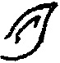  r = TRUMPET 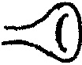  COLOR = GREEN | __ __ |  | __ __
   |  | Dad
  Mom |  | ¹ | ²
  Mom |  | ³ | ⁴
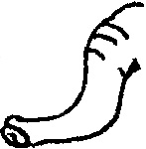  NOSE  N = ELEPHANT  TRUNK    n = PIG NOSE  COLOR = GREEN | __ __ |  | __ __
   |  | Dad
  Mom |  | ¹ | ²
  Mom |  | ³ | ⁴
MOUTH  M = MOUTH 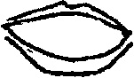  ON STOMACH  m = MOUTH ON FACE  COLOR = BLACK | __ __ |  | __ __
   |  | Dad
  Mom |  | ¹ | ²
  Mom |  | ³ | ⁴
SKIN  J = SCALES 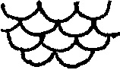  j = NO SCALES  COLOR = PENCIL / PEN LINES | __ __ |  | __ __
   |  | Dad
  Mom |  | ¹ | ²
  Mom |  | ³ | ⁴
WINGS  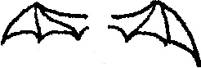  G = BAT WINGS  g = NO WINGS  COLOR = PURPLE | __ __ |  | __ __
   |  | Dad
  Mom |  | ¹ | ²
  Mom |  | ³ | ⁴
ARMS & LEGS  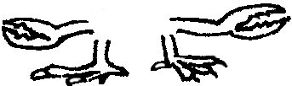  D = 2 LOBSTER CLAW ARMS & 2 CHICKEN FEET  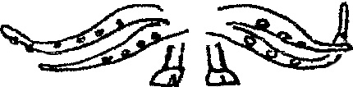  d = 4 OCTOPUS ARMS &  2 HOOFED FEET  COLOR = YELLOW | __ __ |  | __ __
   |  | Dad
  Mom |  | ¹ | ²
  Mom |  | ³ | ⁴

